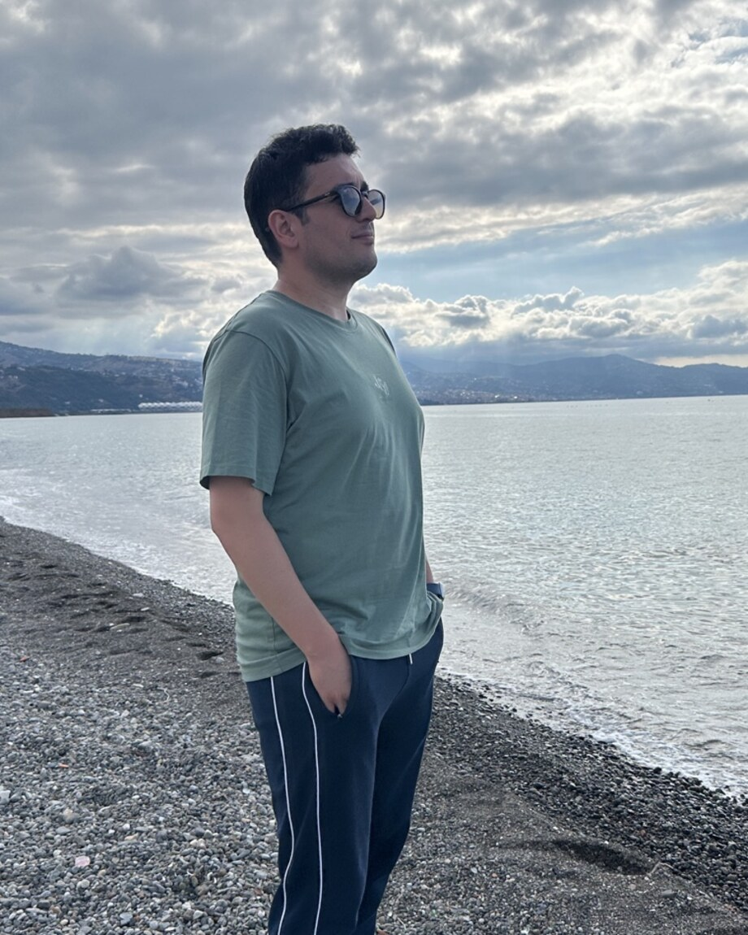
Dr Murat Başeğmez
Geomatics Engineer | GIS Specialist | Researcher
murat.basegmez@gmail.com | muratbasegmez.com
LinkedIn | Google Scholar | DergiPark
Geomatics engineer and researcher specialising in geographic information systems, spatial decision support, machine learning and multi-criteria decision analysis. His academic and institutional work focuses on public real estate, educational investment, sustainable cities, energy planning and disaster-risk reduction.

CURRENT APPOINTMENTS
2026 - Present Branch Manager
Ministry of National Education, Türkiye - Department of Real Estate and Revenue
Leads real-estate management, investment analysis, revenue generation and GIS-based decision-support activities.
2025 - Present Lecturer
Ankara Science University - Department of Management Information Systems
Teaches undergraduate and graduate courses in Geographic Information Systems and Information Systems Analysis and Design.

EDUCATION
2024 PhD - Geomatics Engineering
Hacettepe University
Tez: A sustainable municipal GIS study with urban design criteria and policy
2019 MSc - Surveying Engineering / Geographic Information Systems
Karadeniz Technical University
Tez: Determining optimal school locations using multi-criteria decision-making and geographic information systems: the case of central Uşak
2011 BSc - Geodesy and Photogrammetry Engineering
Ondokuz Mayıs University

PROFESSIONAL EXPERIENCE
2015 - 2026 Geomatics Engineer / Control Engineer
Ministry of National Education, Türkiye
Worked on expropriation, zoning, real-estate law and institutional GIS projects, including spatial data infrastructure activities for MEBCBS.
2013 - 2015 Geomatics Engineer
Trabzon Provincial Directorate of National Education
Worked on expropriation, allocation, easement rights, zoning implementation and development plans.
2011 - 2013 Geomatics Engineer
Private sector - Infrastructure and road projects
Contributed to the planning and implementation of infrastructure and road projects.

RESEARCH INTERESTS AND EXPERTISE
Research: Geographic information systems; spatial decision support; machine learning; multi-criteria decision analysis; game theory; land-suitability analysis; urban planning; climate change; energy; disaster and earthquake risk; educational investment.
Technical: ArcGIS Desktop/Pro; QGIS; NETCAD; Python; remote sensing; spatial modelling; land and real-estate management.

SELECTED PROJECTS
2016 - 2019 MEBCBS
Geographic Information System Project of the Ministry of National Education
Control engineer and acceptance-board member for collecting spatial data from educational institutions and developing the institutional database.
In implementation Risk Reduction in Educational Buildings
Disaster information system
A GIS module assessing school sites and buildings against fire, flood, landslide and other hazards.
2025 - Present TAGEYS
Real-estate and investment decision-support system
A GIS-based system integrating real-estate inventory, investment planning, school site selection, zoning, expropriation and resource development.

COURSES TAUGHT

PEER-REVIEW SERVICE
Engineering Geology; Scientific Reports; Applied Geomatics; Arabian Journal of Geosciences; Forum Geografi; Humanities and Social Sciences Communications; Environment, Development and Sustainability; Sustainable Cities and Society: Advances; Geomatik; Turkish Journal of Remote Sensing and GIS.

INTERNATIONAL PEER-REVIEWED ARTICLES
1. Başeğmez, M. (2026). Onshore energy storage for offshore wind in seismically sensitive coastal areas using geographic information systems and machine learning. Journal of Energy Storage. DOI
2. Başeğmez, M. (2026). Machine learning-integrated spatial decision framework for sustainable offshore wind and marine spatial planning: A Black Sea case study. Engineering Applications of Artificial Intelligence. DOI
3. Doğan, A., Başeğmez, M., & Aydın, C. C. (2026). Integrating machine learning algorithms and game theory for optimized shipyard site selection in Istanbul. Ocean Engineering, 354, 124916. DOI
4. Başeğmez, M. (2026). A hybrid GIS-fuzzy MCDM and game-theoretic framework for strategic offshore wind farm siting: Evidence from the İzmir continental shelf. Expert Systems with Applications. DOI
5. Başeğmez, M., Doğan, A., & Aydın, C. C. (2025). GIS and machine learning integration for optimized school site selection: A hybrid framework with TOPSIS and feature ranking. Applied Spatial Analysis and Policy, 18, 142. DOI
6. Başeğmez, M. (2025). Evaluating shipyard site selection using a GIS-based hybrid multi-criteria approach for sustainable and strategic planning. Operational Research, 25, 111. DOI
7. Başeğmez, M., Doğan, A., & Aydın, C. C. (2025). Management of sustainable urban green spaces through machine learning-supported MCDM and GIS integration. Environmental Science and Pollution Research, 32(18), 11466-11487. DOI
8. Başeğmez, M., & Aydın, C. C. (2025). Climate change impact on green spaces planning in an urban area using a hybrid approach. Environmental Science and Pollution Research, 32(7), 4288-4312. DOI
9. Başeğmez, M. (2025). Strategic multi-criteria framework for nuclear plant siting: Integrating AHP, EWM, and game theory with GIS. Progress in Nuclear Energy, 188, 105897. DOI
10. Doğan, A., Başeğmez, M., & Aydın, C. C. (2025). Assessment of the seismic vulnerability in an urban area with the integration of machine learning methods and GIS. Natural Hazards. DOI
11. Başeğmez, M. (2025). A comprehensive GIS-driven hybrid approach for safe and sustainable radioactive waste disposal facility planning. Annals of Nuclear Energy, 223, 111629. DOI
12. Başeğmez, M., & Aydın, C. C. (2021). The Covid-19 pandemic teaching modalities in Turkey: An evaluation of school gardens and classes. Health Policy and Technology, 10(3), 100546. DOI

NATIONAL PEER-REVIEWED ARTICLES
1. Başeğmez, M. (2026). İklimsel koşulların yürünebilirlik üzerindeki mekânsal etkilerinin çok kriterli karar verme yöntemleri ve oyun teorisi ile değerlendirilmesi: İzmir Konak ilçesi örneği. Türk Uzaktan Algılama ve CBS Dergisi, 7(1), 166-194. DOI
2. Başeğmez, M. (2025). Açık deniz rüzgâr enerjisi için Rize kıta sahanlığında CBS destekli hibrit çok kriterli saha seçimi. Türk Uzaktan Algılama ve CBS Dergisi, 6(2), 315-342. DOI
3. Akbaba, M. Y., Atay, G., Başeğmez, M., & Aydın, C. C. (2023). Bicycle and walking path site selection for a sustainable transportation system: A case study of Ege neighborhood in Mamak. GEOMATİK, 8(2). DOI
4. Topcu, G. Z., Bayır, K., Cavıldak, Z. E., Başeğmez, M., & Aydın, C. C. (2023). Evaluation of green spaces suitability analysis with GIS-based AHP and TOPSIS methods. GEOMATİK, 8(3). DOI
5. Doğan, A., Başeğmez, M., & Aydın, C. C. (2023). Determination of proxy properties using GIS analysis that can replace geophysical and geotechnical measurements. GEOMATİK, 8(3). DOI
6. Başeğmez, M., & Aydın, C. C. (2022). Evaluation of school gardens and classes via GIS in the COVID-19 process in Turkey. GEOMATİK, 7(3). DOI

CONFERENCE PAPERS
1. Başeğmez, M. (2025). Integrating Climate Change into Walkability Assessments: A Multicriteria Approach Using AHP and GIS. 1st BİLSEL International Sütçü İmam Scientific Research Congress, Kahramanmaraş. Oral presentation, abstract.
2. Başeğmez, M. (2025). Integrating Climate Change into Walkability Assessments: A Multicriteria Approach Using AHP and GIS. 2nd BİLSEL International Safranbolu Scientific Research Congress, Karabük. Abstract.
3. Başeğmez, M., Doğan, A., & Aydın, C. C. (2025). Assessing earthquake vulnerability in Eskişehir through multi-criteria decision analysis, game theory and GIS. TUFUAB XIII Technical Symposium, Zonguldak. Full paper.
4. Başeğmez, M., & Aydın, C. C. (2023). Investigating the effects of climate change on walkability within sustainable transportation. TUFUAB XII Technical Symposium, Sivas. Abstract.
5. Başeğmez, M., Yıldırım, V., & Bediroğlu, S. (2019). Optimal school site selection using GIS and AHP: Central Uşak case study. TMMOB 6th Geographic Information Systems Congress, Ankara. Full paper.
6. Başeğmez, M., & Taşdemir, İ. (2019). Planning and managing school sites with MEBCBS: The Pendik district of Istanbul. TMMOB 6th Geographic Information Systems Congress, Ankara. Full paper.
7. Şahin, O., Coşkun, H. G., & Başeğmez, M. (2019). Examining the Sarıyer case in planning educational resources with GIS. TMMOB 6th Geographic Information Systems Congress, Ankara. Full paper.
8. Başeğmez, M., Taşdemir, İ., & Gül, Ç. (2017). Challenges and recommendations in defining site-selection criteria for educational facilities. 16th Turkish Mapping Scientific and Technical Assembly, Ankara. Poster.

